How to use Epi Pen or Voice-Guided Epinephrine Auto-Injector
Epinephrine is a Vasoconstrictor and aids in Blood pressure support
It can treat severe asthma attacks and allergic reactions (including anaphylaxis) in an emergency situation.

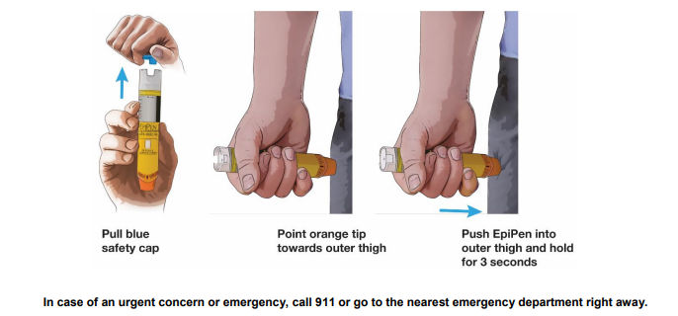
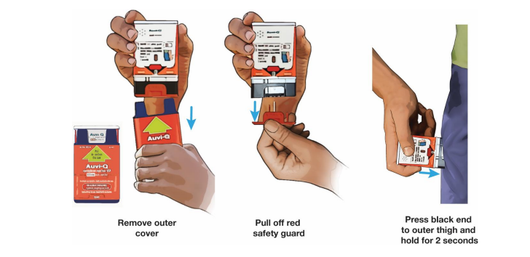
Learn more and be trained from www.cprflorida.net

