**How to use Narcan and Naloxone for Opioid Overdose**

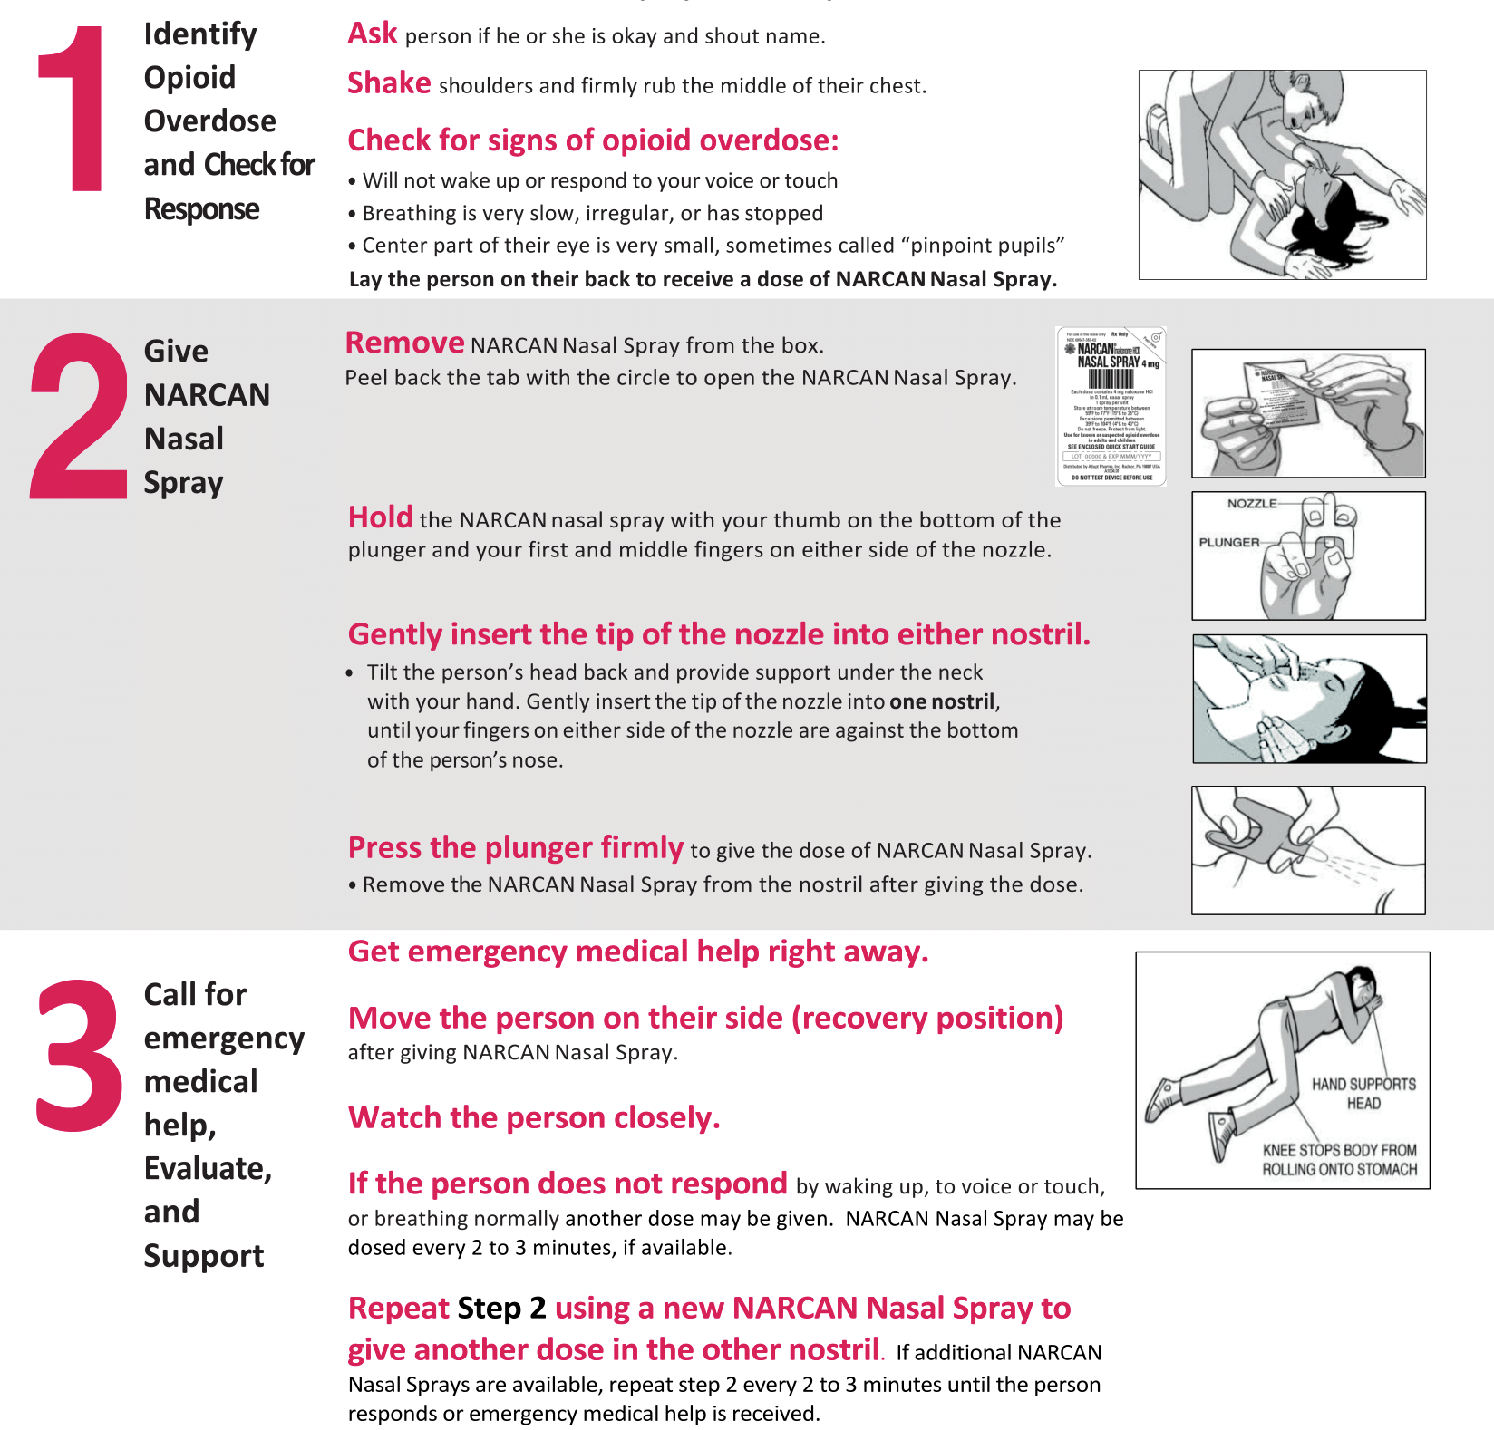

**Learn more and get trained at www.cprflorida.net**