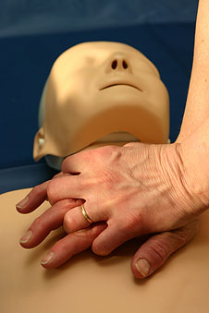

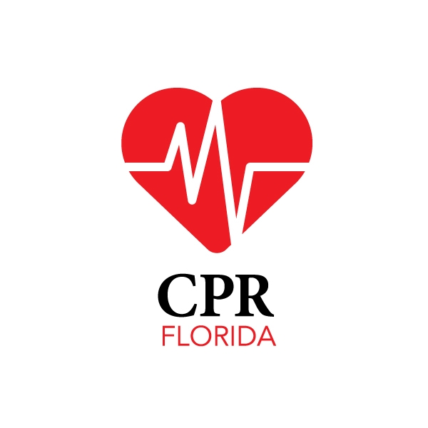
CPR AND SPORTS MEDICINE SERVICES, LLC
Main Phone: 1-888-388-9250
Website: www.cprflorida.net
e-mail: info@cprflorida.net
** THIS IS A SHORT, OVERALL REVIEW OF CPR, AED AND FIRST AID. WE ARE GOING GREEN! TO VIEW ENTIRE REVIEW PACKET, GO TO WWW.CPRFLORIDA.NET/CPRREVIEW.HTML **

Yes, CPR has changed again in late 2010! Here is the brief overview:

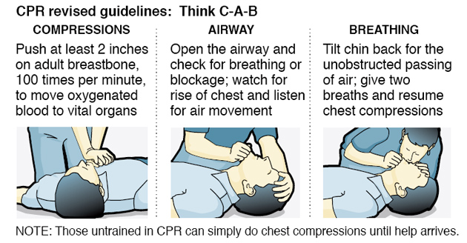
CPR is similar to before, but the main change is this: Call 911, if you think they are not breathing or responsive, give 30 compressions, then give 2 one second breaths. C.A.B. = Compressions, Airway, Breathing. If you can not give breaths, don’t want to give breaths or are not trained, just call 911 and do 30 compressions and take a few seconds break and then repeat. If you can, continue compressions over and over until advanced help arrives.

ADULT CPR New Guideliens 2010 - 2011 – For Lay responders
Step 1. Check the victim for unresponsiveness. Tap and shout, “Are you OK?” If there is no response, Call 911 and return to the victim. In most locations the emergency dispatcher can assist you.
Step 2: Call 911
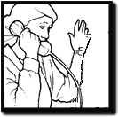 Follow directions of ems or dispatcher on the phone then…
Step 3 . PUMP – CHEST COMPRESSIONS:
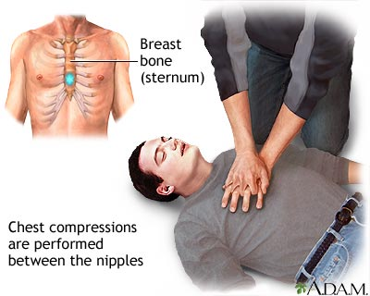
Push hard and fast, in the center of the chest on the sternum, 30 times. Push at a rate of at least 100 per minute. Push down for adults 2 inches or more. If you hear a slight crack or pop, that is ok…keep going if the person is still not responding, moaning, or has a sign of life.
Step 4: Open the airway.
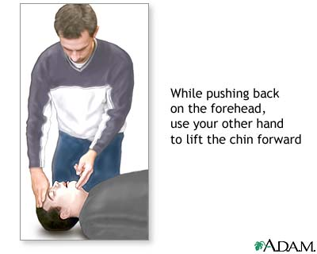
TILT HEAD, PINCH THE NOSE & GIVE 2 BREATHS, EACH LASTING 1 SECOND LONG.
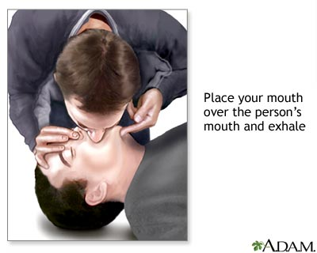
If not breathing normally, pinch nose and cover the mouth with yours and blow until you see the chest rise. Give 2 breaths. Each breath should last 1 second.
Step 5. PUMP – CHEST COMPRESSIONS AGAIN! Continue to give 30 chest compressions and then 2 breaths until help arrives, person has a sign of life or the AED is ready to use.
** The pulse check is no longer taught or expected of laypersons, Just Healthcare Providers.
Here are pictures of how to do a pulse check. Again, this is for BLS or Healthcare Providers Only.
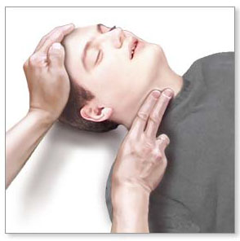 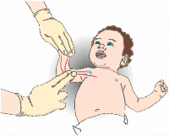
*Pulse check for adults is on the neck called the carotid artery for healthcare providers.
*Pulse check for infants is in the upper arm between the bicep and tricep below the armpit. This is the brachial artery. Remember, CPR is for those who have NO pulse and are NOT breathing. When you give cpr, you are giving them breaths and compressions. You give breaths to help give oxygen to the victim and you give chest compressions to act like their heart and help circulate the blood to the body.
RESCUE BREATHING:
If the victim DOES have a pulse, but they are not breathing, you do rescue breathing. Rescue breathing is giving breaths only. This is for healthcare professionals only. For adults, give one breath every 5-8 seconds. For children and infants, give one breath every 3-5 seconds.
CHILD CPR:
Step 1: Tap and shout and the child…yell, “Are you OK?”. If no sign of life…go to a phone.
Step 2: Call 911
Follow directions of ems or dispatcher on the phone then…
Step 3: Compressions on the chest:
If your child is not breathing and has no pulse, begin Child CPR.
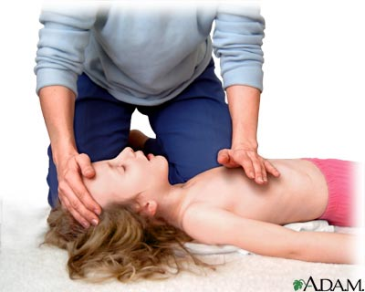 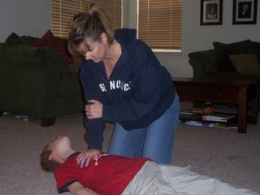
With your child still lying on her back, put the heel of your hand on the lower third of her breastbone, or center of the chest just below the nipple line. (*Use only 1 hand if possible, or use 2 hands…one hand on chest and the other on your wrist, but do not press as hard or as deep as adult cpr) Depress her chest between 1 1/2 inches to 2 inches. Repeat 30 times at a rate of at least 100 per minute. (Count "one and two and three.") After 30 compressions, with your child's head still tilted, pinch her nose shut, put your mouth over hers, and give two slow, one second gentle breaths. Repeat …
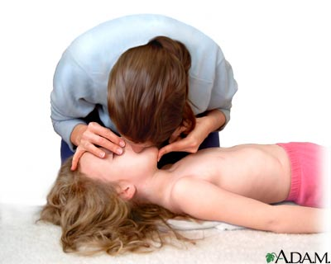
If there is no response, call 911 and do 30 compressions going down about 1.5 to 2 inches and then give 2 breaths. (Healthcare professionals: To check for a pulse, gently place your first two fingers on your child's neck and feel for the carotid artery that's next to her throat. Feel for a pulse for 5-10 seconds. If there is a pulse, give one breath or use a bag-valve mask BVM every 3-5 seconds.)
CPR FOR INFANTS: (Age 1 or younger)

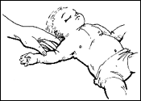Shout and Tap the baby’s leg or arm.
If there is no response, call 911 and position the infant on his or her back.
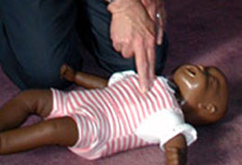Use 2-3 fingers to give 30 chest compressions in the center of the chest, between the nipples.

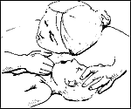
Open The Airway. Open the airway slightly using a head tilt, chin lift method.

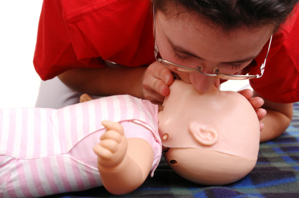Give 2 gentle breaths making sure your mouth covers their nose and mouth
If the baby is NOT breathing give 2 small gentle breaths. Cover the baby's mouth and nose with your mouth. Each breath should be about 1 second long. You should see the baby's chest rise with each breath. Continue 30 compressions and 2 breaths until EMS (911) arrives.
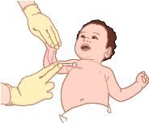
Healthcare Professionals: Check for a pulse in the inside of their arm (brachial pulse).
INFANT 2 PERSON CPR
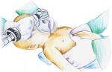 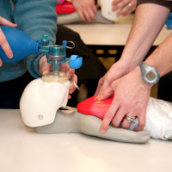
One person does bag valve mask and the other does the two hands encircling the chest technique to give 15 compressions and then 2 breaths. Remember, one person cpr for an infant is 2 breaths and 30 compressions. When two people are doing cpr, it is 2 breaths and 15 compressions.
CHOKING INFANT:
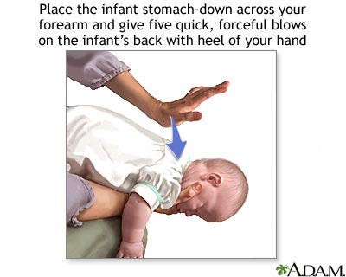 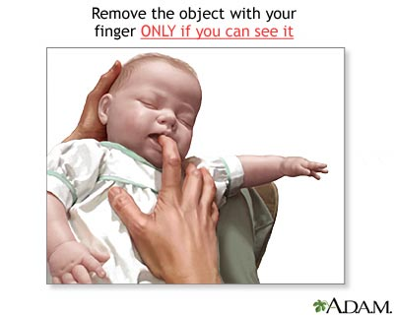 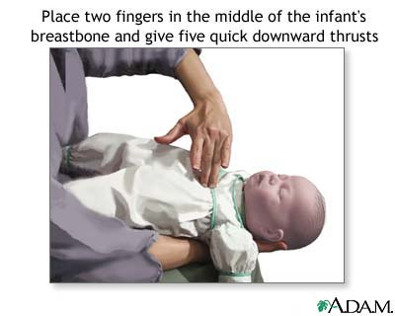
If your baby can't clear her airway on her own and you believe something is trapped there, carefully position her face down on your forearm, with your hand supporting her head and neck, and rest the arm holding the baby on your thigh. Support her so that her head is lower than the rest of her body. Then give her five back blows between her shoulder blades with the heel of your hand to try to dislodge the object. Next, place your free hand (the one that had been delivering the back blows) on the back of her head and along her spine and carefully turn her over supporting the head and neck. Support her face-up, with your forearm resting on your thigh, keeping her head lower than the rest of her body. Place two or four fingers in the center of your baby's breastbone and give five chest thrusts, each about 1 inch deep. Continue the series of back blows and chest thrusts until the object is forced out, she begins to breathe on her own, she becomes unconscious, or advanced medical help arrives and takes over.

CHILD CHOKING:
If a child is choking, bend over and do the Heimlich. You can also go on both of your knees and perform the maneuver.
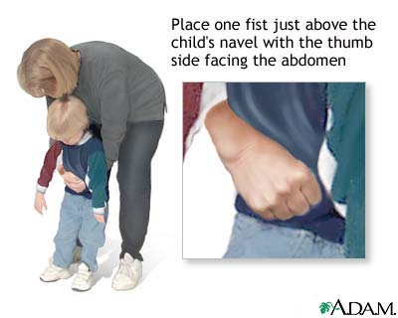 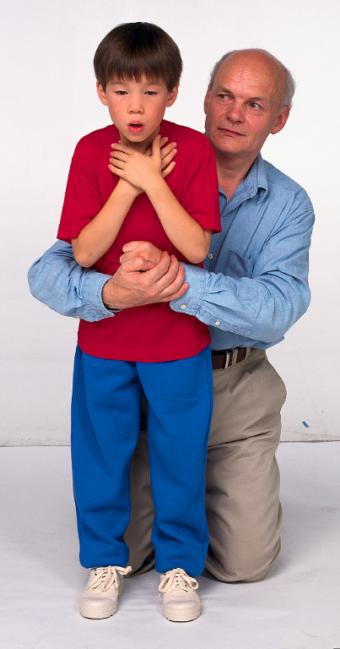

Choking for a Conscious Adult:
Determine if the person can speak or cough.  If not, proceed to the next step | 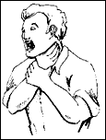
If they can not breath, or are making wheezing or no sounds at all, stand behind them, place one fist just above the belly button, then wrap your other hand around it. | 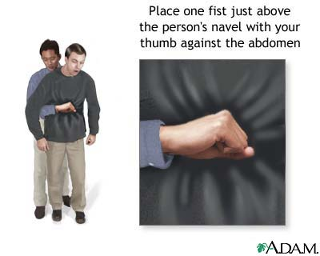
Next, pull up and in, very hard, over and over until the object comes out or until the victim passes out. If they pass out…call 911 and START CPR! | 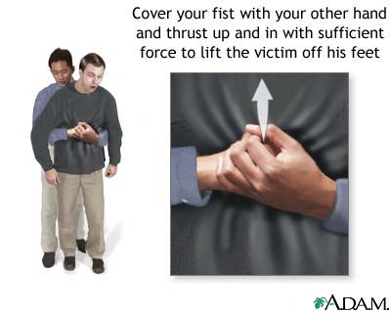
*** A chest thrust may be used for markedly obese persons or in late stages of pregnancy | 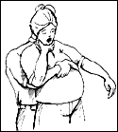
*** If you are by yourself… | 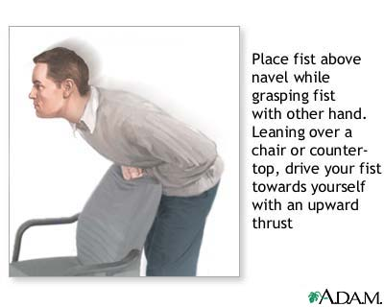
AED Defibrillator Training
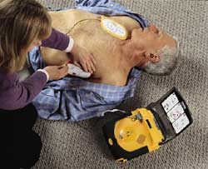 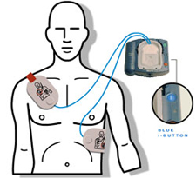
What is an automated external defibrillator (AED)?
An AED is a device about the size of a small laptop computer that analyzes the heart's rhythm for any abnormalities and, if necessary, directs the rescuer to deliver an electrical shock to the victim. This shock, called defibrillation, may help the heart to reestablish an effective rhythm of its own.
How does an AED work?
An AED is easy to operate. It uses voice prompts to instruct the rescuer. Once the machine is turned on, the rescuer will be prompted to apply two electrodes provided with the AED to the victim's chest. Once applied, the AED will begin to monitor the victim's heart rhythm. If a "shockable" rhythm is detected, the machine will charge itself and instruct the rescuer to stand clear of the victim and to press the shock button.
The time to the first defibrillation shock is the most critical factor in determining survival rates for sudden cardiac arrest (SCA). With every minute that goes by, survival rates decrease by about 10%. That leaves a window of ten minutes in which to potentially save your life or the life of someone you know, after which survival rates average less than 2%.
The best results for defibrillation occur in the first three minutes, measured from the moment the victim collapses to when the defibrillation shock is delivered.
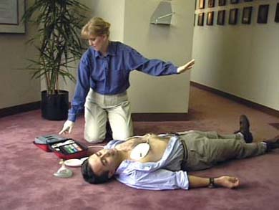
How to work and AED:
Put one pad on upper right of the chest and one on the lower left side of the body (side of body near stomach). When you place pads and then connect the cord, it will check for a shockable pulse. If there is a shockable pulse, it will say Shock Advised!. If so, tell everyone to Clear! and then press shock. If no pulse, you press shock again. After 1 shock with no pulse, you MUST do cpr for 2 minutes and then let it reanalyze for a heart rhythm. Continue until ems arrives.
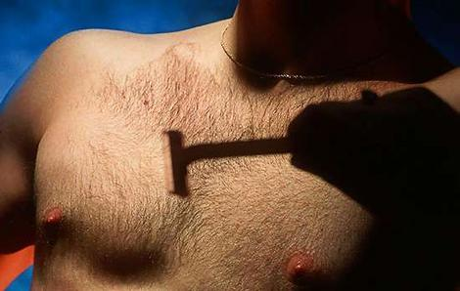 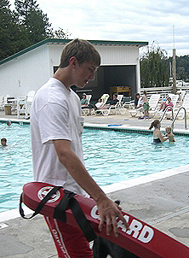 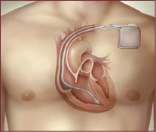
hairy chest on water away from pacemaker
Precautions when using an AED:
Do Not: Use the aed in water, in a big puddle, on bleachers, on a very hairy chest (quickly shave it), on top of a pacemaker, do not press shock when others are touching the victim.
FIRST AID:
Always start first aid with: Check, Call, Care.
*Check the scene and see if anyone can help, to see if there is other dangers and safe for you to help them.
*Call 911 right away.
*Then give Care to the victim.
Shock:
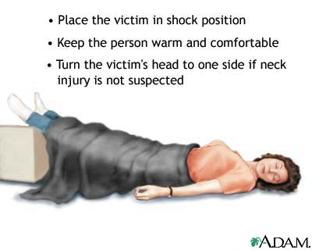
Shock in adults and older children - Shock is a life-threatening condition. Immediate medical care can make the difference between life and death.
Early signs of shock (most of which will be present) include:
- * Lightheadedness or a feeling that you are about to pass out.
- Restlessness, confusion, or signs of fear.
- Shallow, rapid breathing.
- Moist, cool skin or possibly profuse sweating.
- Weakness.
- Thirst, nausea, or vomiting.
Also, a person in shock usually has an abnormal increase in heart rate and an abnormal decrease in blood pressure.
Late signs of shock include:
- Changes in the person's level of consciousness, such as sudden unresponsiveness, faintness, loss of consciousness, or behavior changes.
- A pale face or blue lips or earlobes.
Shock may occur in response to a sudden illness or injury. When the body loses too much blood or fluids, the circulatory system cannot get enough blood to the vital organs, and shock results. Shock is often associated with heavy external or internal bleeding from a serious injury. Spinal injuries can also cause shock.
Food or bite allergies and anaphylactic shock:
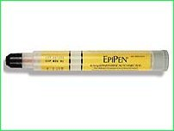| 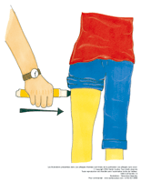
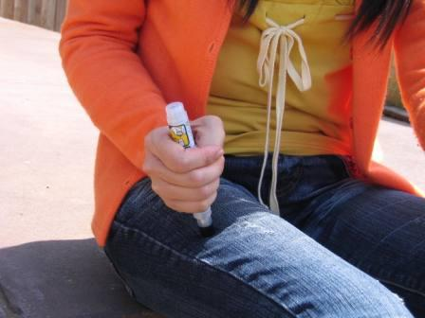
Many people have food allergies or are allergic to bites and stings. They may need an Epi Pen as soon as possible. An epi-pen has medicine inside a tube that has a needle. You place your hand around the pen (do not touch the bottom or top when using it), take off the top gray cap (round) and point the narrower end with the needle inside towards the person's leg. They can do it themselves, or you can do it for them. Jab the pen through their clothes or on the bare skin. Hold in place for 10 seconds then rub for 10 seconds and throw away in a sharps container. The person will feel relief, but still make sure you called 911.

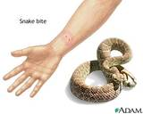
Snake Bites: Snake bites can be deadly. It's important to react quickly to bites. If emergency medical services can be reached, request help through 911. If in a remote area, getting the victim to medical care is vital. North America is home to several different species of venomous snakes. The most common is the rattlesnake. Antivenin is available, but it must be used as early as possible.
- Safety first! Get away from the snake. That's probably why it bit in the first place. Follow universal precautions and wear personal protective equipment if you have it.
- Call 911 immediately! Waiting until the pain may lead to permanent tissue damage. Remember that calling 911 on a cell phone is different than a regular phone.
- Do not elevate. Keep the bite below the level of the heart.
- Wash the area with warm water and soap.
- Remove constricting clothing and jewelry from the extremity. The area may swell and constricting items will cause tissue death.
- If the snake is an elapid species (coral snakes and cobras), wrap the extremity with an elastic pressure bandage. Start from the point closest to the heart and wrap towards the fingers or toes. Continue to keep the bite lower than the heart.
- Follow the basics of first aid while waiting for responders to arrive. Be especially concerned about the potential for shock.
Remember:
- NO CUTTING & SUCKING! Those snake bite kits from the drug store don't work. Cutting into the wound will just create infections.
- Try not to let the victim move much or walk or run at all if possible. They should be transported only.
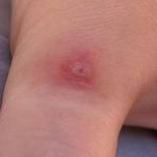
Insect Bites: Insects, spiders, and scorpions are capable of causing very painful reactions. Bites and stings can be dangerous, but are rarely fatal. Bug bites are dangerous because of the possibility of anaphylaxis.
Spider bites and scorpion stings can be more worrisome. The reality, however, is that most bites are from unidentified bugs. There are specific treatments for bee stings and removing ticks. Here's How:
- Stay Safe! Follow universal precautions and wear personal protective equipment if you have it. If a stinger is present, follow the directions for treating bee stings.
- Apply an ice pack to the site of the sting. Alternate on and off to prevent tissue damage - usually 20 minutes on and 20 minutes off.
- If the victim exhibits any of the following, consider the possibility of anaphylaxis:
  - Itching, swelling, heart palpitations, weakness, dizziness, hives, redness, etc.
- If the victim has any involuntary muscle movements, call 911 immediately.
- Try to identify the bug. If the bug is dead, scoop it up and take it with you to the emergency department. Be careful, even dead bugs have venom.
- For pain relief, try sting swabs (compare prices). Acetaminophen and ibuprofen are also good for pain.
- Bark scorpion stings can cause numbness and tingling in the tissue around the bite. If the site is tingling or burning, see a doctor.
Heart Attack
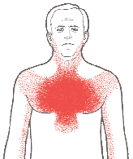| 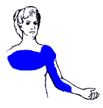
A heart attack (myocardial infarction) occurs when heart muscle is damaged or destroyed because it does not get enough oxygen-rich blood to sustain life. Just as the heart supplies oxygen and nutrients to other parts of the body, blood vessels called coronary arteries supply needed blood to the heart. If one or more coronary arteries or the blood vessels that feed blood into the major arteries are blocked or narrowed, the heart muscle is deprived of oxygen. If the oxygen supply is cut off for more than several minutes, the heart cells suffer permanent injury or death.
Heart Attack Warning Signs Some heart attacks are sudden and intense — the "movie heart attack," where no one doubts what's happening. But most heart attacks start slowly, with mild pain or discomfort. Often people affected aren't sure what's wrong and wait too long before getting help.
Myocardial Infarction is not the same as cardiac arrest, or sudden cardiac death (SCD)!
SCD is caused by a deadly heart rhythm disorder (arrhythmia) called ventricular fibrillation (VF).
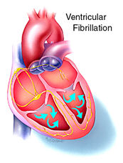 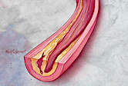
What Causes a Heart attack?
Heart attacks most often result from coronary heart disease (also called coronary artery disease or ischemic heart disease). The most common cause is atherosclerosis ("hardening of the arteries"), a build-up of fatty deposits called plaque. Over time, plaque clogs and narrows the arteries and other blood vessels, and slows or blocks the flow of blood to the heart and elsewhere. Sometimes, the surface of plaques can rupture or tear, which can cause blood clots to form that block the arteries. A complete or near-complete blockage of the coronary arteries results in a heart attack.
Here are signs that can mean a heart attack is happening: · Chest discomfort. Most heart attacks involve discomfort in the center of the chest that lasts more than a few minutes, or that goes away and comes back. It can feel like uncomfortable pressure, squeezing, fullness or pain. · Discomfort in other areas of the upper body. Symptoms can include pain or discomfort in one or both arms, the back, neck, jaw or stomach. · Shortness of breath. May occur with or without chest discomfort. . If you or someone you're with has chest discomfort, especially with one or more of the other signs, don't wait longer than a few minutes (no more than 5) before calling for help. Call 9-1-1...

Stroke:
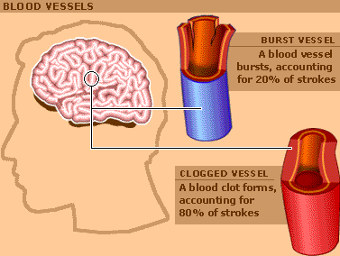
What is a Stroke?
Stroke is a type of cardiovascular disease. It affects the arteries leading to and within the brain. A stroke occurs when a blood vessel that carries oxygen and nutrients to the brain is either blocked by a clot or bursts. When that happens, part of the brain cannot get the blood (and oxygen) it needs, so it starts to die.
What Are the Types of Stroke?
Clot (Ischemic) | Bleed (Hemorrhagic) | TIA (Transient Ischemic Attack)
Stroke can be caused either by a clot obstructing the flow of blood to the brain or by a blood vessel rupturing and preventing blood flow to the brain. Diagnosis of Stroke
When someone has shown symptoms of a stroke or a TIA (transient ischemic attack), a doctor will gather information and make a diagnosis.
Stroke Warning Signs:
Sudden numbness or weakness of the face, arm or leg, especially on one side of the body · Sudden confusion, trouble speaking or understanding · Sudden trouble seeing in one or both eyes · Sudden trouble walking, dizziness, loss of balance or coordination · Sudden, severe headache with no known cause If you or someone with you has one or more of these signs, don't delay! Immediately call 9-1-1 or the emergency medical services (EMS) number so an ambulance (ideally with advanced life support) can be sent for you. Also, check the time so you'll know when the first symptoms appeared. It's very important to take immediate action. If given within three hours of the start of symptoms, a clot-busting drug can reduce long-term disability for the most common type of stroke.
HEAT ILLNESSES:
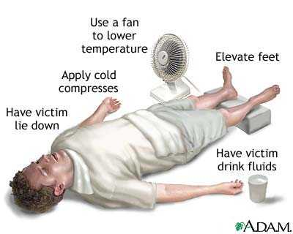
Heat stroke:
is the most dangerous of the heat-related illnesses. If not treated immediately, it can be fatal. The exact cause of heat stroke isn't clear, and unlike heat exhaustion, it strikes suddenly and with little warning. When the body cooling systems fails, the core temperature rises quickly. Signs of heat stroke include a core body temperature above 40.5C / 105F, hot, wet or dry skin, lack of sweating, and a very fast pulse, and mental status changes. Basically if the person is hot and not in good mental state, passing out or losing consciousness, think first that it may be heat stroke and call 911.
Heat Exhaustion:
Heat exhaustion may be difficult to differentiate from heat stroke, but it typically occurs when one is exposed to heat for a prolonged period of time. The body may become overwhelmed by heat when its mechanism (sweating) for keeping cool breaks down. Symptoms of heat exhaustion include nausea, dizziness, weakness, headache, pale and moist skin, weak pulse, and disorientation. The key difference between heat stroke and heat exhaustion is that there are no mental status changes (other than mild confusion) in those suffering from heat exhaustion. Stopping activity, and cooling the body are the key treatments for heat exhaustion.
Preventing Heat Illness
- Always acclimatize for up to a week when exercising in hot weather conditions. This allows your body to gradually adapt to the heat, hydrate well, do not exercise when it is very hot, wear light clothing.

Frostbite:
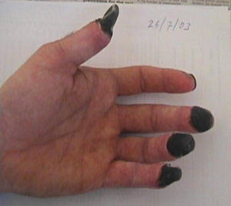
Frostbite on fingers (skin is dead).
Occurs when skin is damaged from extreme cold. You want to re-warm the hands by a fire or with warm water.
Do not use hot water or rub them together (do not massage it). This will damage the skin more. If it becomes worse where the ends of the fingers or toes are becoming black, you need to go to the hospital or call 911 right away.
Splinting or Immobilizing breaks and sprains:
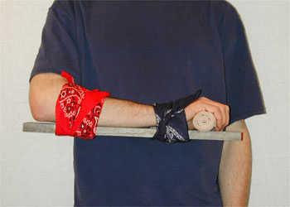 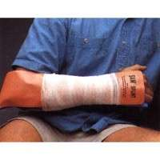 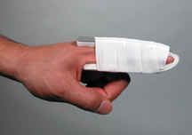
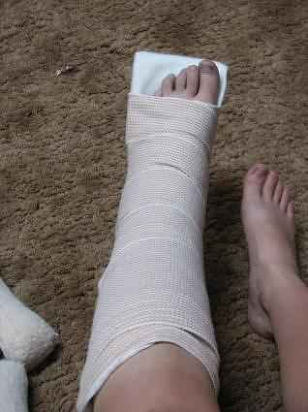 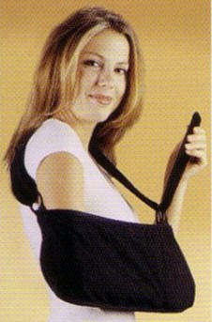
Dial 9-1-1 immediately and immobilize the broken bone with a splint. A functional splint can be made of almost any material (wood, plastic, etc.) as long as it is rigid and is longer than the broken bone. To apply the splint simply lay it along the broken bone and wrap it against the limb with gauze or a length of cloth, starting at a point farthest from the body. Do not wrap it too tight as this may cut off blood flow. (snug, but not too tight!)
If the break is in the forearm, loosely wrap a magazine or a thick newspaper around the break and use a sling fashioned from gauze, ace bandage or a strip of cloth to keep the elbow immobilized.
A break in the lower part of the leg requires two splints, one on each side of the leg (or at least the chin). If suitable material is not available, you can use the victim's healthy leg as a makeshift splint. If you have to splint it, remember to splint it ABOVE AND BELOW the injury.
As much as possible, keep the victim from moving and until an ambulance arrives, remember ICE:
- "I" is for ice - if possible apply an ice pack or ice cubes to the injured area. This will keep down the swelling and reduce pain.
- "C" is for compression - if the wound is bleeding, apply direct pressure with a clean cloth to reduce blood flow.
- "E" is for elevation - try to keep the injured area as high above heart level as possible.
BURNS:
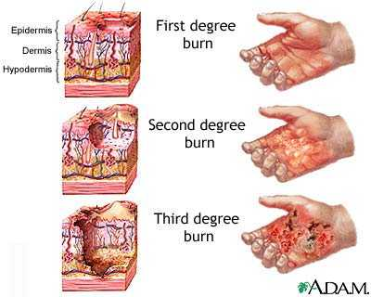 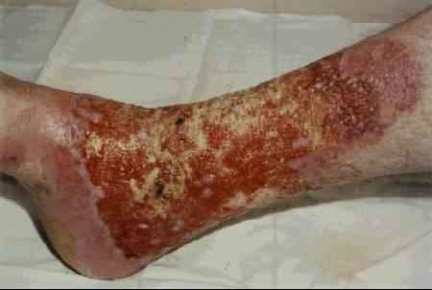
picture of a 3rd degree burn
A burn victim will require different type of care depending on the type and extent of his injury. Burns vary greatly from a common, fairly harmless sunburn to a potentially life-threatening 3rd degree burn caused by open flames or electrocution. Here's how to distinguish the three different types of burn injuries and how to care for each:
- 1st degree burns are usually accompanied by redness and some swelling of the skin.
Treat a minor burn by first cooling the affected area. If possible, keep the injury under cool running water for at least 10 minutes. If running water is not available place the burn in a container of cold water such as a bucket, tub or even a deep dish. Using a cool, wet compress made of clean cloth will also work if nothing else is available. Keeping the burn cool will reduce pain and minimize the swelling. If the injury is on the part of a body where jewelry or snug clothing is present, carefully remove them before it begins to swell. Apply a moisturizing lotion or Aloe Vera extract and dress the burnt area with loosely wrapped sterile gauze.
- 2nd degree burns will result in deeper, more intense redness of the skin as well as swelling and blistering.
This type of burn should be treated just as a 1st degree burn but because the damage to the skin is more extensive, extra care should be taken to avoid infection and excessive scarring. Replace the dressing daily and keep the wound clean. If a blister breaks use mild soap and warm water to rinse the area. Apply antibiotic cream such as Neosporin to prevent infection before redressing in sterile gauze.
- 3rd degree burns may appear and feel deceptively harmless as the victim may not feel much pain due to complete destruction of all layers of skin and tissue as well as nerve endings. The damaged area may appear charred or ash-color and will instantly start to blister or "peel".
If the victim's clothing is on fire, douse him with non-flammable liquid. Dial 9-1-1. Do not remove burnt clothing from the victim as this will expose open wounds to the elements and potential infection. If possible, cover the victim's injuries with wet sterile cloth to reduce the pain and swelling. If you notice that the victim is going into shock and loses consciousness, you will need to perform CPR.
Cuts or Lacerations:
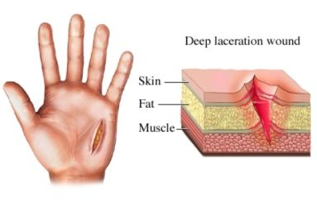 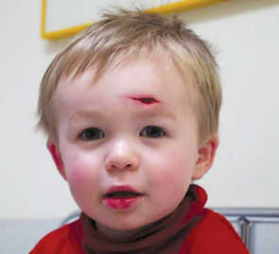
cut on baby's head (laceration)
The first and most important step when treating minor cuts and scrapes is to thoroughly clean the wound with mild anti-bacterial soap and water. You can use sterilized tweezers to remove any debris that remains embedded in the wound after rinsing. This will reduce the risk of an infection and possible complications. If the debris is abundant or can't be removed for some other reason, a trip to the emergency room will be necessary.
Water may induce bleeding by thinning the blood. If while rinsing the wound you notice increased blood flow, use gauze or a clean cloth to apply gentle, continuous pressure until the blood clots.
Although hydrogen peroxide is commonly used as a disinfectant for minor cuts and scrapes, it is actually not very effective and may even delay the healing process by irritating a person's living cells. You can use hydrogen peroxide but apply it around the open wound, not directly to it. An antibiotic ointment such as Neosporin is a better alternative - it will keep the wound from getting infected and speed up the healing process.
Dress the wound with a bandage or sterile gauze to keep dirt and bacteria out. Change the dressing frequently and rinse the wound as often as necessary to keep it free of dirt. Continue to monitor the wound for several days. If the injured area turns red or puffy, or if excessive pain persists, then it may've become infected and will require a physician's attention. Do not simply dismiss cuts as minor injuries as some may be quite serious if not tended to by a professional. If the wound is very deep or the bleeding is profuse, it may require stitches in order to heal properly.
Nosebleed:
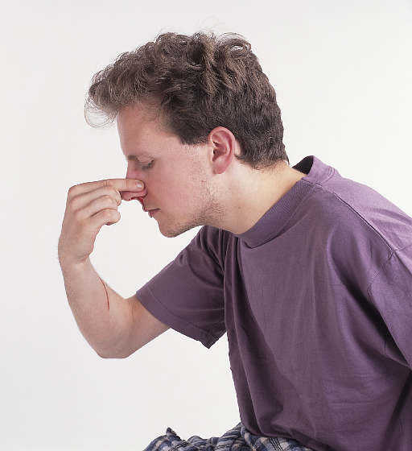
A human nose is rich with small fragile blood vessels which are susceptible to damage. A nosebleed may be caused by a fall, a strike to the nose, or even from breathing excessively dry air. If the nosebleed is not a symptom of a more serious injury, it is rarely dangerous and can usually be stopped by applying continuous pressure.
- Do NOT tilt the victim's head backward.
- Pinch the nostrils shut and press the tip of the nose against the bones of the face.
- Maintain pressure for 5 to 10 minutes.
- Once the bleeding has stopped, the victim should avoid blowing his nose or otherwise straining himself for at least an hour.
Bleeding:
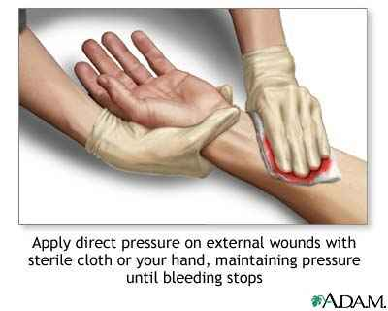
1. Step one…apply direct pressure and hold for a few minutes. If this does not work..
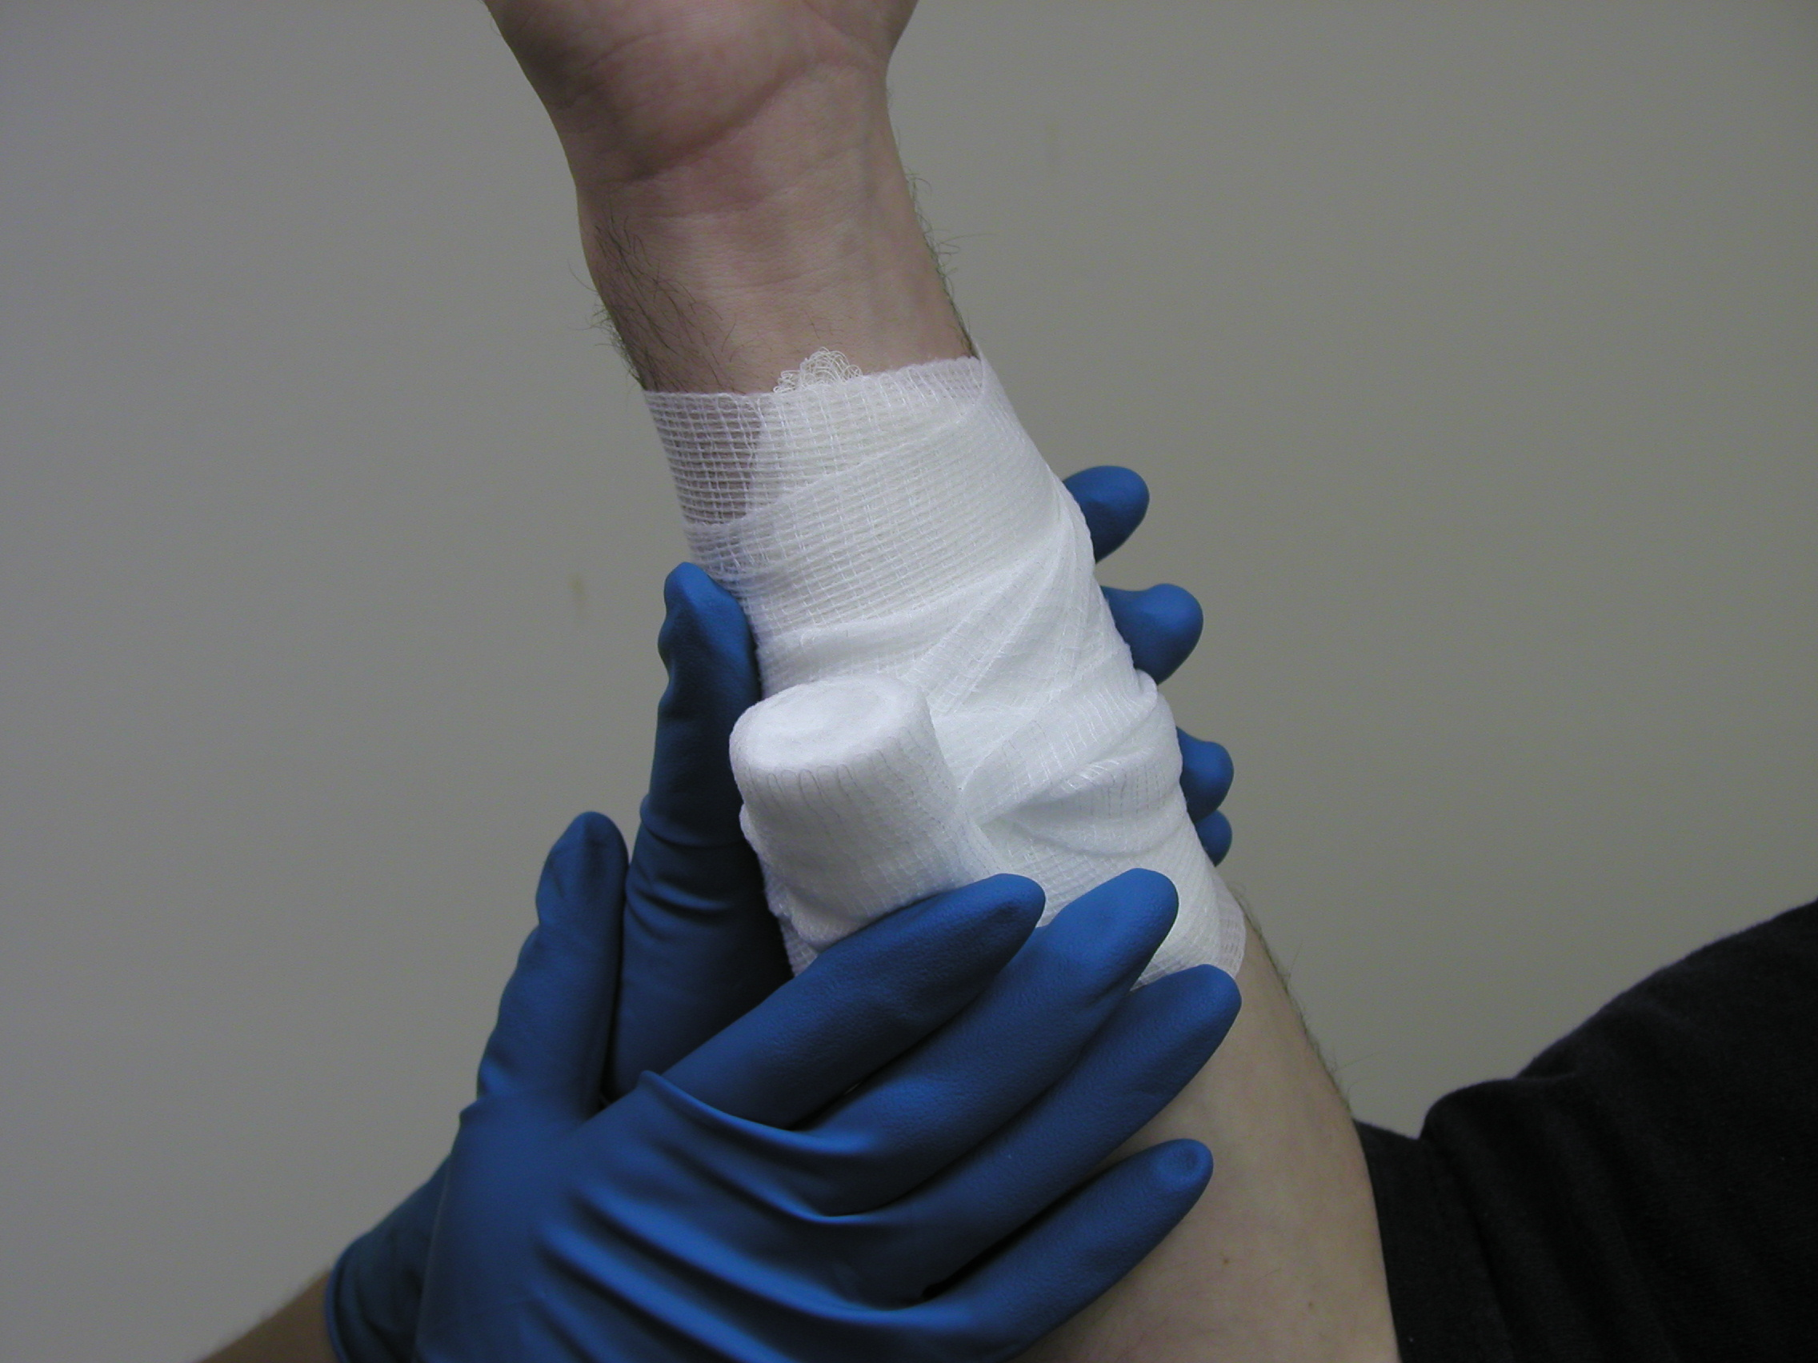
2. Step two, apply rolled gauze bandage and make it snug, but not too tight. The person can go back to work or leave it like this until other medical attention takes over.
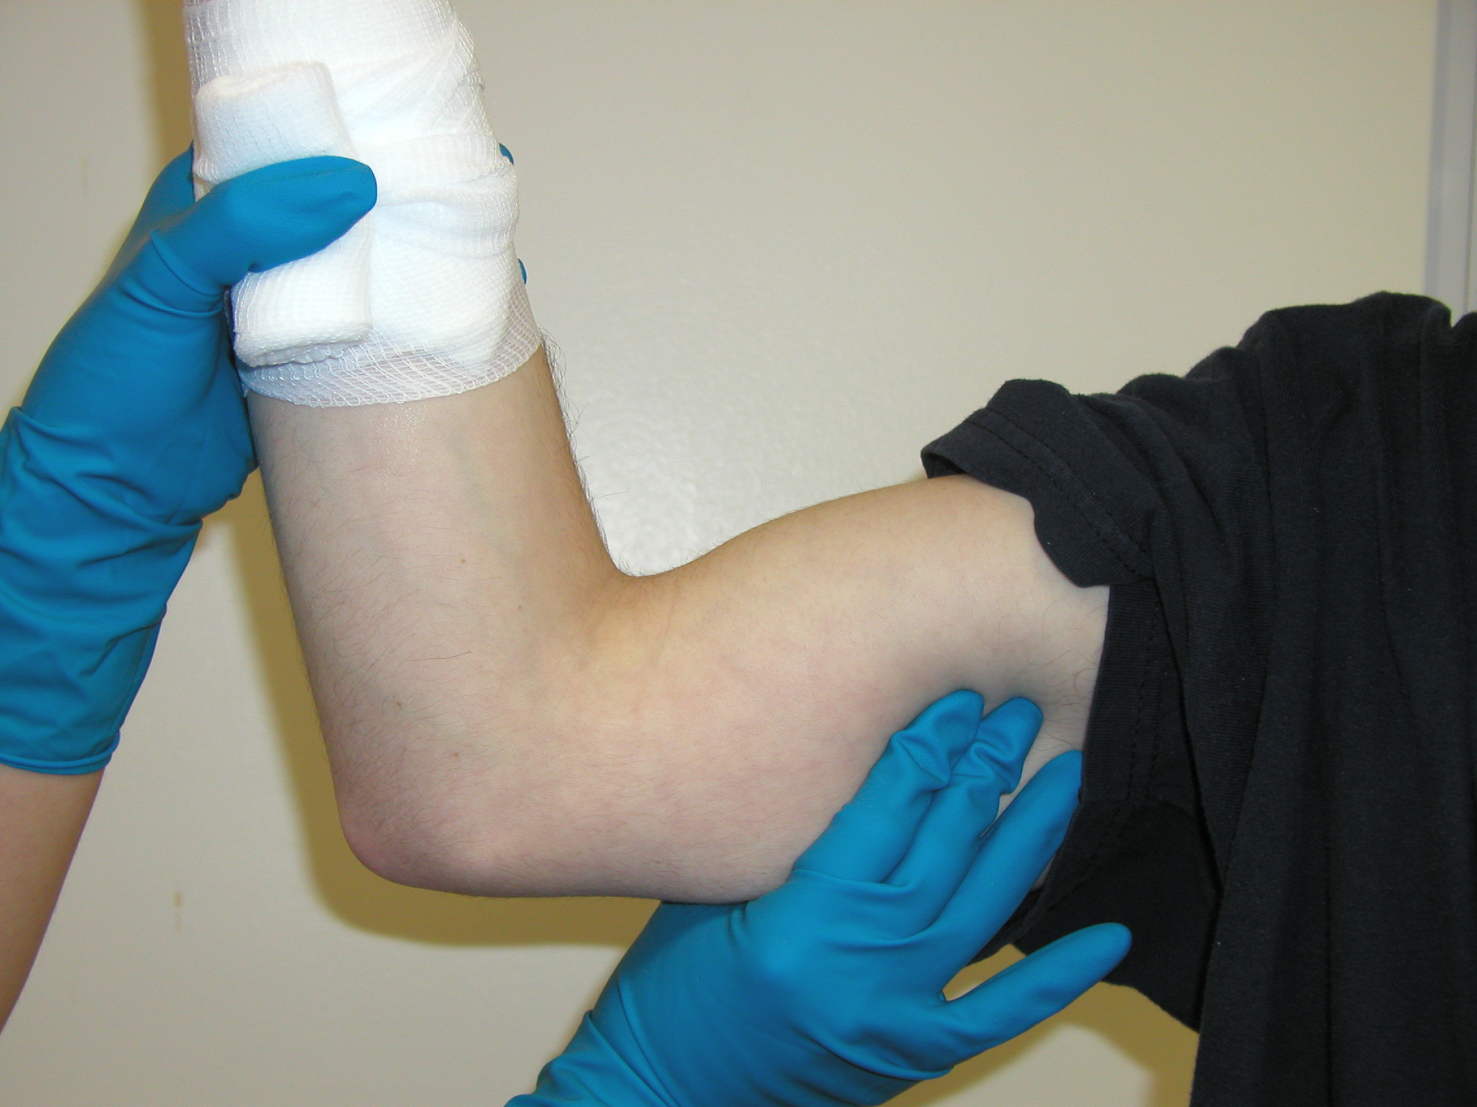
3. Step three. If bleeding is still severe or not slowing down, you use a pressure point in the arm (brachial - between bicep and tricep near the armpit) or leg (femoral - inside of groin in the leg) until bleeding stops or slows down or until advanced ems arrives.
Remember with bleeding: Always wear gloves and dispose of everything in a bio hazard bag (red). To stop bleeding, first use gauze. If it keeps bleeding, add more gauze on top and raise the injured area if it is not broken. Finally, use a pressure point (not tourniquets) if you must and seek further medical attention.
Wash Hands vs. Hand Sanitizer
 VS. 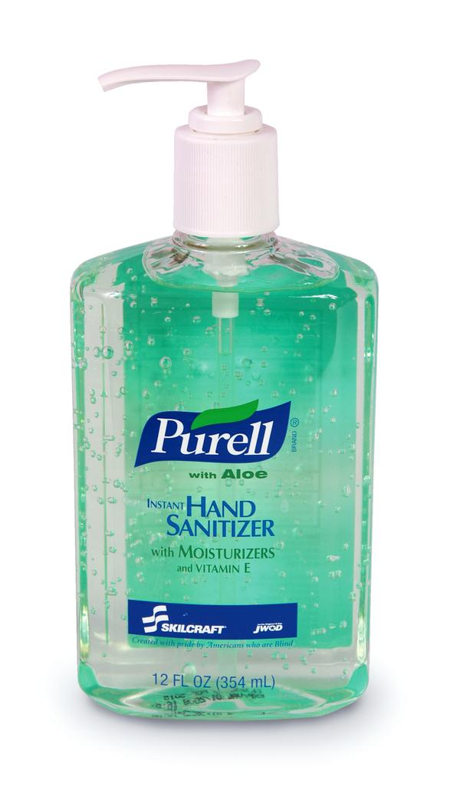
Antibacterial hand sanitizers are marketed to the public as an effective way to "wash one's hands" when traditional soap and water are not available. These "waterless" products are particularly popular with parents of small children. Manufacturers of hand sanitizers claim that the sanitizers kill 99.9 percent of germs. Since you naturally use hand sanitizers to cleanse your hands, the assumption is that 99.9 percent of harmful germs are killed by the sanitizers. Recent research suggests that this is not the case.
Interestingly enough, the Food and Drug Administration, in regards to regulations concerning proper procedures for food services, recommends that hand sanitizers not be used in place of soap and water but only as an adjunct.
We recommend that to properly sanitize the hands, soap and warm water should be used. A hand sanitizer can not and should not take the place of proper cleansing procedures with soap and water.
- Diabetes:
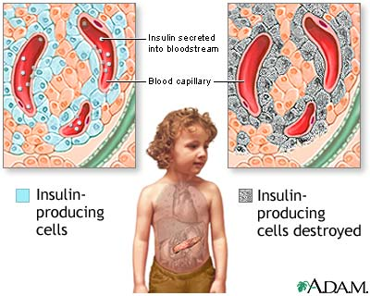
Diabetes:
What it is: Diabetes mellitus is a chronic and currently incurable condition in which the body is unable to regulate the glucose (sugar) levels in the blood. It occurs when the pancreas doesn't make enough or any of the hormone insulin, or when the insulin produced doesn't work effectively. In diabetes, this causes the level of glucose in the blood to be too high. It is managed by a healthy lifestyle and balanced diet, sometimes requiring tablets or insulin.
Two conditions:
- Hyperglycemia (high blood sugar)
- Hypoglycemia (low blood sugar)
How to recognize it:
- A history of diabetes – casualty may recognize onset of ‘hypo’ attack
- Hunger (A missed or late meal can cause the onset of a ‘hypo’ attack for a diabetic.)
- Shallow breathing , weakness, hunger, tremors, strange behavior, rapid pulse, deteriorated level of response, etc.
- 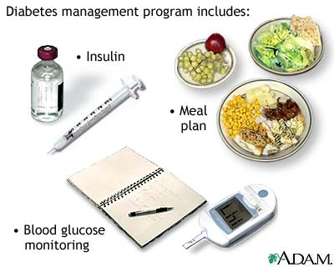
Diabetic’s warning card, glucose gel, tablets, or insulin syringe in casualty’s possession.
Dangerously low blood sugar (Severe hypoglycemia)
Low blood sugar, known as hypoglycemia, can occur in diabetics when they use too much insulin, exercise too hard or too long, or have not eaten enough food. Hypoglycemia can develop quickly in people with diabetes.
Symptoms of low blood sugar typically appear when the sugar level falls below 70. Watch for:
- Weakness , Shaking, Sweating, Headache, Nervousness, Hunger
If these symptoms occur and you have a blood sugar test kit available, do a blood sugar check. If the level is low, the person with diabetes should eat something with sugar: fruit juice, several teaspoons of sugar, a cup of skim milk, or regular soda. If you don't have a test kit handy, sugar should be eaten anyway — it can't hurt. Symptoms should subside within 15 minutes. If the symptoms don't subside, more sugar should be eaten and the sugar level tested again.
AFTER the symptoms subside, more substantial food can be eaten. Eat simple sugar FIRST to get the situation under control. Even if you or your child is hungry, "real" food should not be eaten until the sugar level comes up — real food won't produce enough sugar and takes too long to digest.
If casualty improves, give him/her more to eat and drink.
Watch for complications:
- If condition does not improve look for other possible causes.
- If consciousness is impaired, do not give anything to eat or drink
If unconscious, carry out ABCD’s, remembering to call for an ambulance.
Bloodborne Pathogens:
There are several diseases that are caused by blood borne pathogens (BBP's). While many BBP's are fairly exotic and you may never encounter them, a few BBP's are fairly common and present a risk to you if you come in direct contact with potentially infectious materials such as human blood and certain body fluids.
Occupational Safety and Health Administration (OSHA) has recognized that health care workers and others, who may in contact with human blood or blood associated materials (Other Potentially Infectious Materials or OPIM for short) has recognized this occupational hazard and created the "Blood borne Pathogen Standard".
This standard has served as the basis for implementing policies and practices to minimize your risk of exposure to BBP's, specifically to Hepatitis B virus (HBV), Hepatitis C virus and Human Immunodeficiency Virus (HIV). These policies and practices, if followed, are an effective means to reducing your risk of exposure to other pathogens as well.
How to take off gloves:
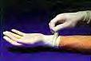Take off first glove starting at the top near the wrist.
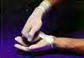Make the glove inside out and place it inside the other gloved hand.
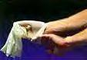Remove the other glove by slipping your bare fingers inside the glove at the top of the wrist and pull it off so that it is inside out. The gloves should be inside of each other. Any lightly soiled bandages or band aids should be inside the gloves. Put in biohazard bag.
Blood and Other Potentially Infectious Materials (OPIMs)
HIV and HBV may be found not only in human blood, but also in other potentially infectious materials including the following body fluids:
- blood products, semen, vaginal secretions, cerebrospinal fluid, synovial fluid, body fluid with blood in it.
Other items found in the clinical or laboratory setting are also considered to be other potentially infectious materials (OPIM) and they include:
- any unfixed tissue or organ, other than intact skin, from a living or dead person
- cell or tissue cultures that may contain blood borne pathogens as outlined in LBNL's Exposure Control Plan
- organ cultures and culture medium or other solutions that may contain HIV or HBV blood from experimental animals infected with HIV,
- HBV or other BBPs.
It is a required practice to use Universal Precautions when handling these body fluids and materials. The following body fluids are not expected to be infectious sources of blood borne pathogens unless they are visibly contaminated with blood:
- urine , feces, vomit, tears, sweat, sputum, nasal secrections.
Although these body fluids do not currently require universal precautions, good personal hygiene practices are highly recommended when handling these materials.
Transmission of Blood borne Pathogens
Blood borne pathogens can be transmitted when infectious blood or OPIM is introduced into the bloodstream of a person. Transmission of blood borne pathogens in the workplace can occur through the following routes of transmission:
- Parenteral exposure - this means that the infected blood or OPIM is introduced directly into your body through a break in the skin. Examples include: a needle-stick injury or a cut with a piece of contaminated glass.
- Mucous membrane exposure - this means that the infected blood or OPIM enters your body through contact with a mucous membrane found in your eye, nose or mouth.
Blood borne pathogens may also be transmitted through:
- Sexual contact
- Infected women may expose their newborn children to BBP's through amniotic fluid, through blood during the birthing process, and (less likely) through breast milk.
Human Immunodeficiency Virus (HIV). HIV is the virus that gradually weakens the immune system of the infected person, leaving that person unable to fight off other infections. This leads to acquired immunodeficiency syndrome (AIDS) and will ultimately cause death. HIV-infected persons may have no symptoms or may experience symptoms such as swollen lymph nodes, fatigue, weight loss, diarrhea, persistent dry cough and fever.
HIV & AIDS Trends
According to CDC statistics, HIV-related illness was the leading cause of death among young adults between the ages of 25 and 44 years old in 1995. It is still the second leading cause of death for this age group today.
Hepatitis B Virus (HBV). HBV Hepatitis B virus (HBV) is a virus that causes an infection of the liver potentially leading to liver disease, liver cancer and possibly death. Symptoms of HBV infection may range from no symptoms, to brief flu-like symptoms, to jaundice and serious illness. If symptoms do occur, they may not be evident until 2 to 6 months after the person is infected. However, studies have shown that an infected person can be infectious to others several weeks before the onset of symptoms.
HBV Infection Trends
CDC estimates that between 140,000 and 320,000 people become infected every year in the U.S. Approximately one-half of all people who become infected do not have any symptoms of infection.
Approximately 10% of all people who become infected may become "carriers" of HBV. This means that they may suffer from infection at a later time (chronic infection). They can also be infectious to others for the rest of their lives while not necessarily demonstrating any symptoms of HBV infection themselves.
Occupational Exposure
Individuals whose jobs involve handling blood and OPIM are at a much greater risk of becoming infected with HBV than HIV.
Why you may ask?
It is because there are many more HBV-infected people than HIV-infected people in the community. Thus the chance of exposure to HBV is greater. Hepatitis B virus is much more infectious than HIV. This difference in infection risk is best illustrated by the following statistics:
If you had a needle stick accident and were exposed to infected blood, your chance of acquiring an infection would be:
HIV ~0.3% or 3 in 1000
HBV ~30.0% or 300 in 1000
According to CDC, your risk for acquiring an HBV infection is 100 times greater than for HIV. When considering the risk of occupational exposure to HBV, keep in mind that a safe and effective vaccine is available to you.
Reducing the Risk through Vaccination
A 3-shot vaccination series is available for hepatitis B virus. The vaccination is highly effective and safe. As an employee encountering blood and potentially infectious materials in the course of your job, you are entitled to the vaccination at no cost.
Hepatitis C Virus (HCV)
Hepatitis C virus (HCV), also formerly known as "non A-non B", is another pathogen that you need to be aware of if you have occupational exposure to human blood or other potentially infectious materials.
Hepatitis C virus has been found in all parts of the world. The virus appears to be transmitted most efficiently through parenteral exposure to blood from an infected individual. Common examples of transmission events are: receiving a blood transfusion from an infected source or sharing intravenous drug needles with an infected individual.
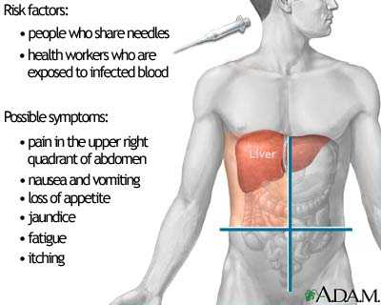
Comparing HBV and HCV
Like HBV, symptoms of HCV can range from no symptoms or flu-like symptoms to jaundice and even death in rare instances. Also similar to HBV, HCV has a carrier state which can lead to chronic infection and liver disease. Unlike HBV, there is currently no vaccine for HCV available and immune globulin administered after exposure does not appear to be very effective in preventing HCV infection.
Transmission Risk
Although the risk of HCV transmission is still being defined, the risk of transmission by the following routes appears to be low:
- regular household contact situations
- sexual contact
- passing the infection from mother to unborn child
Cases of transmission of HCV to health care workers have occurred through accidental needle sticks, cuts with sharp instruments, and splashes to the eye with human source material.
How long does HIV or Hepatitis b or c last on surfaces or in the air? HIV does not last long at all in the air or on surfaces. It must be contained in the blood to infect someone. Hepatitis A, hepatitis B and hepatitis C are all forms of viral hepatitis—an inflammation of the liver caused by a virus. However, there are a number of characteristics that differentiate these diseases. Hepatitis A - is spread by a fecal-oral route or by eating and drinking contaminated food or water. In younger patients the infection often goes unnoticed. Most patients recover fully after a short illness. As a result of their infection, they develop lifelong immunity. Hepatitis B - is transmitted through infected blood and body fluids. It can be passed, for example, from mother to child during delivery. It can also be transmitted sexually, and is therefore a sexually transmitted disease. Hepatitis B is often spread through injection drug use. The majority of adults infected with the hepatitis B virus recover completely, and as a result of their infection, develop lifelong immunity to the virus. However, approximately 10% of adults and 90% of infants who become infected with hepatitis B cannot get rid of the virus and are considered to have chronic hepatitis B. These people become long-term carriers, and although they may be symptom free for many years, they may develop cirrhosis or liver cancer later in life. Is there a cure for hepatitis C? Current treatment includes a combination of anti-viral drugs (interferon and ribavirin) and approximately 40% of people receiving this treatment are able to completely eliminate the Hepatitis C virus from their bodies. Success ranges from 20-80% and depends on many factors: the amount of scarring in the liver, the amount of virus in the body and the specific genotype of hepatitis C. Most people with hepatitis C can live a healthy life for many years. Only about 20% of hepatitis C patients develop cirrhosis or liver cancer. The key to successful treatment and management of the disease is early diagnosis and treatment. Is there a vaccine for hepatitis C? There is no vaccine for hepatitis C at the present time. Once in the body, HCV can literally change its coat (or outer capsule) in a process called mutation. It is this outer coating that helps the body or vaccine identify a virus and attack it. Thus, developing a vaccine for hepatitis C has become a moving target. You would need a different vaccine for each mutation of the virus. Researchers are currently tackling this challenge but a vaccine is not expected in the near future. How long can HCV live outside the body and transmit infection? Recent studies suggest that HCV may survive on environmental surfaces at room temperature at least 16 hours, but no longer than 4 days. What do you use to remove HCV from environmental surfaces? You should clean up any blood spills - including dried blood, which can still be infectious - using 1:10 dilution of one part household bleach to 10 parts of water for disinfecting the area.
Healthcare Provider BLS CPR (Professional Rescuer: (advanced section)
CPR For Adults:
Same as layperson, but after you give your initial 2 breaths, check the carotid pulse…then decide to continue with cpr or only rescue breaths.
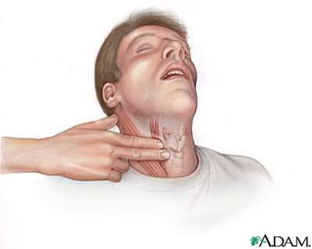
For Infants, feel brachial pulse:

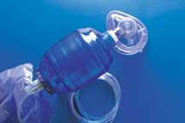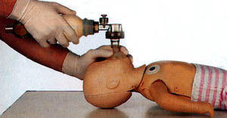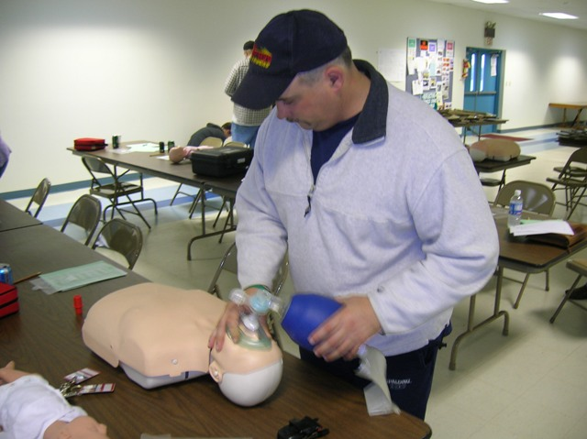

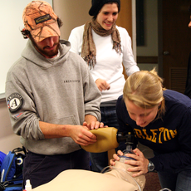 | Bag-Valve Mask (BVM)  Like the Pocket Mask, the BVM includes a face mask with a one-way valve.  The key difference is that the air for respirations comes from the bag and reservoir,  which can be attached to an oxygen tank for high concentration oxygen, rather than  from the rescuers own lungs. This method of delivery is often much more effective,  especially if there are multiple rescuers on scene.

Rescue Breaths and CPR with BVM:
*When doing cpr, use the bvm as you would giving normal mouth to mouth breaths. Push in for 1 second then release the bag. If you are doing rescue breaths, push in for 1 second then release and count out loud until you reach 3-5 seconds for a child/infant then repeat. For adults, wait 5-7 seconds then repeat.

All Healthcare Provider BLS students must know adult, child and infant cpr. You must know advanced first aid. You must also know 2 person cpr, bag/valve mask, cpr one way valve mask, and AED.
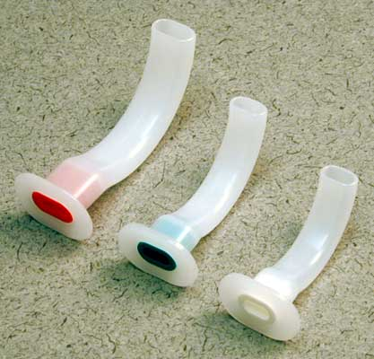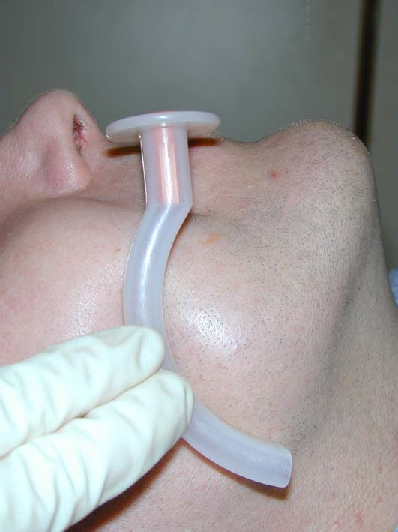
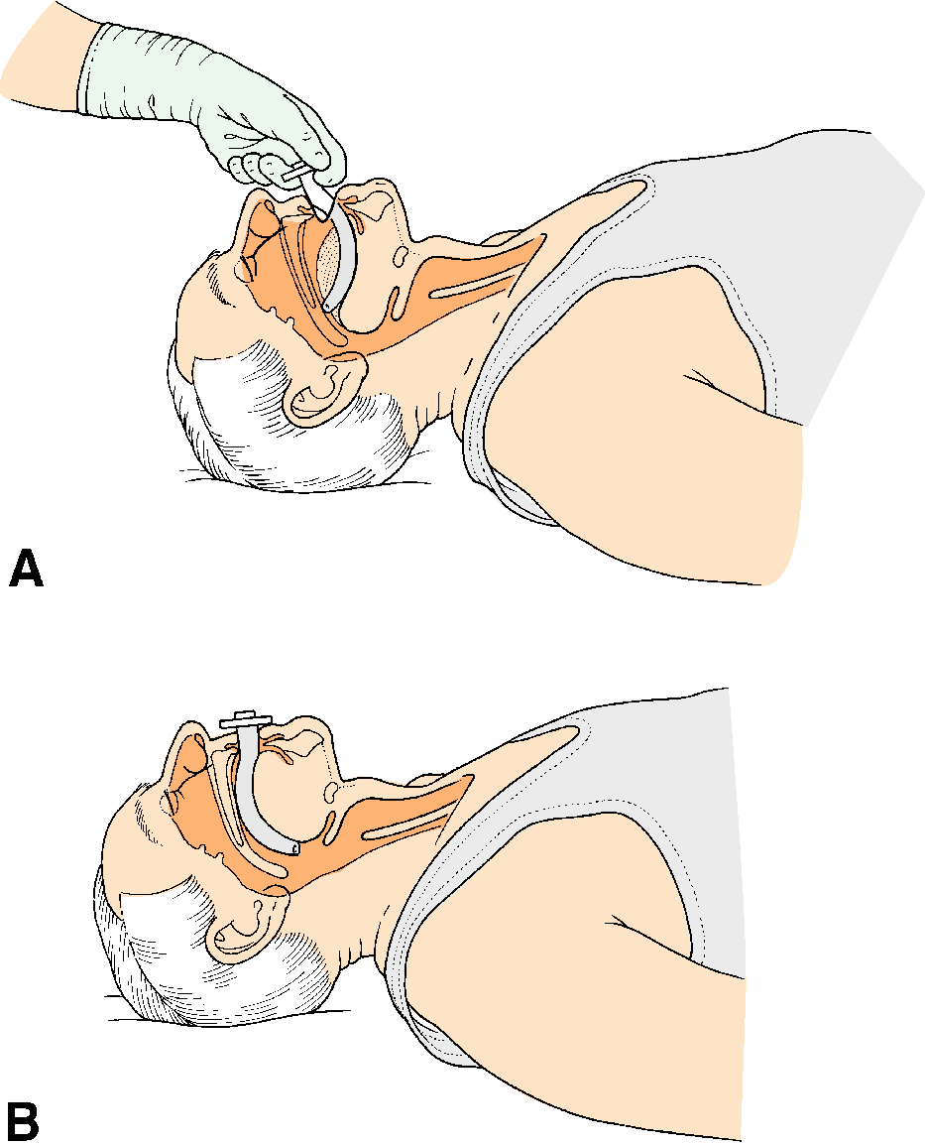
Oral-Pharyngeal Airways adjuncts (OPAs)
These curved pieces of rigid plastic are inserted into the mouth of a patient
who has lost their gag-reflex (often because they are unconscious) to protect
them from occluding their own airway as the muscles of the tongue relax. Estimate the correct size required by selecting the airway that approximates most closely to the vertical distance between the patients incisor teeth and mandibular angle or mouth to bottom tip of the bottom of the ear.
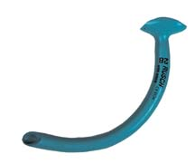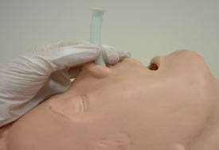
Nasal-Pharyngeal Airway adjuncts (NPAs)
These soft flexible rubber tubes are lubricated and inserted in through a patient's
nostril with the same purpose as the OPAs above. They are designed to provide a
protected airway through which the patient may breathe, naturally or with the help of emergency rescuers. The advantage to using an NPA is that a patient with an
intact gag-reflex who will reject an OPA may still be provided with an airway.
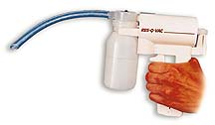
Suction Devices: The Res-Q-Vac
If a patient develops fluid in their mouth or throat, it is often necessary to remove the
fluid in order to prevent aspiration into the lungs. This is accomplished using a suction
device. Most ambulances will carry an electric suction device, but for reasons of
portability our organization uses a hand-pump device which accomplishes the same task.
Administration of Oxygen
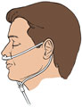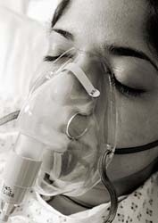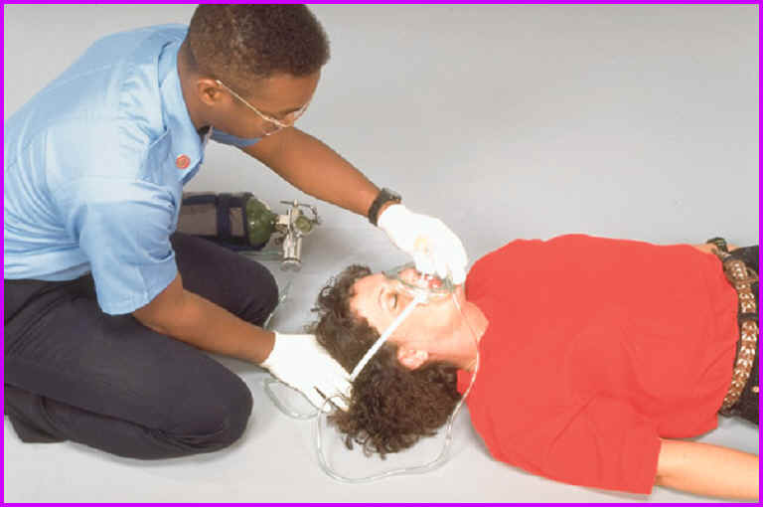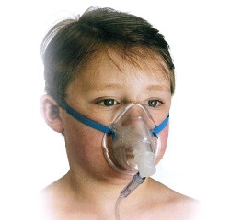
Oxygen is most commonly given by nasal cannula, which is a plastic tubing that reaches to the nostrils. It is also given by a mask, which covers the mouth and nose. In both cases, the nasal cannula or mask are attached to plastic tubing which attaches to a source of oxygen: oxygen tanks of various sorts or oxygen concentrators. Oxygen is given at a certain speed or rate which is measured in liters per minute. An injured or ill person can benefit greatly from receiving air with a higher oxygen concentration.
The air a person normally breathes contains approximately 21 percent oxygen. The concentration of oxygen delivered to a victim through rescue breathing is 16 percent.
Without adequate oxygen, hypoxia, a condition in which insufficient oxygen reaches the cells, will occur.
Signs and symptoms of hypoxia include: Increased breathing and heart rate. Consciousness, restless, cyanosis, chest pain, etc
Always provide emergency oxygen to a victim having difficulty breathing if it is available, you are trained to use it and local protocols allow.
Emergency oxygen should be considered if
An adult is breathing fewer than 12 breaths per minute or more than 20 breaths per minute.
A child is breathing fewer than 15 breaths per minute or more than 30 breaths per minute.
An infant is breathing fewer than 25 breaths per minute or more than 50 breaths per minute.
To deliver emergency oxygen, you need:
An oxygen cylinder. A regulator with pressure gauge and flowmeter.
A delivery device, such as a nasal cannula, resuscitation mask, non-rebreather mask or a BVM (more below about these).

