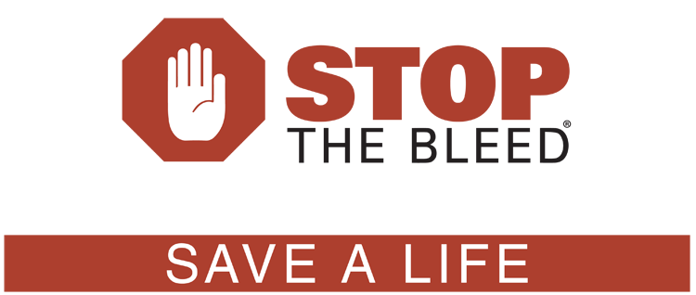

Thank you for taking the Stop the Bleed Class with CPR Florida Instructors.
Use this alone or in conjunction with one of our cpr aed and first aid classes.

Remember in any emergency to first call 911 to get EMS on the way, but they can also assist you over the phone and give you any necessary first aid or emergency instructions to help save more lives.

Get more information at www.cprflorida.net

