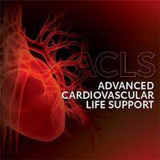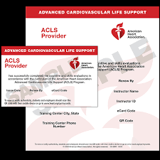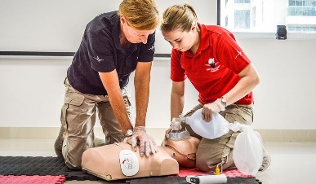
ACLS TOOLS FOR SUCCESS! Stress free classes from cprflorida.net
- Stroke Alert = CT < 20 min
- Complexes are wide and similar = Monomorphic V-tach
- OPA measured from mandible to corner of mouth
- NPA measured from corner of mouth to nose
- No bleed, onset < 2hrs = TPA ASAP
- After we shock, resume CPR, starting with chest compressions
- Atonal gasps (fish out of water) = sign of cardiac arrest
- If chest pain patient is stable, most important diagnostic is 12 lead ECG
- When cooling to 32-36 degrees C, keep them on ice for 24 hours
- Going, going, gone is a Second Degree Type I
- Always complete you BLS rapid assessment prior to initiating CPR
- Recent stent placed, no crushing chest pain = ACS
- First drug in every cardiac arrest is 1 mg, Epinephrine 1:10,000 IV push
- Second drug for V-Fib/V-Tach is either Amio 300 mg or Lidocaine 1 to 1.5 mg/kg
- If comatose after ROSC, cool them down to hypothermia
- Unstable V-Tach with a pulse, the intervention is synchronized cardioversion
- Increase CCF by hovering and charging the defibrillator 15 seconds before rhythm check
- If you aren’t proficient in a skill, ask for a new task
- Capnography is the only have to confirm a tube
- Capnography can also confirm good quality CPR (if intubated)
- Less than 10 mmHG on EtCO2, possible poor CPR, switch compressors
- If P waves and QRS complexes don’t match, most likely 3rd Degree Block
- Stop a mistake before it happens, always address it immediately
- Adenosine dosages are 6mg then 12 mg
- PR internal stays the same and then a QRS is dropped = 2nd Degree Type II
- Rapid response teams recognize declining patients for early intervention
- If unsure, repeat an order back for clarification
- 162 to 325 mg of ASA for Chest Pain
- If I look like NSR and I have no pulse, I’m PEA = Give Epi every 3-5 min
- 90 mmHg is the target BP
- Coach wants high quality CPR
- If less than 94% SpO2 on room air, give O2
- Fast rhythms and hypotensive = Synchronized Cardioversion
- When closing the loop, repeat it back
- Team Leader should clearly delegate
- Too much ventilation, not enough cardiac output
- Nothing should take longer than 5-10 seconds
- Cardiac arrests should be taken to cardiac capable facilities
- Door to balloon time should be 90 minutes or less
- CPR should be done at least 5 cycles in a 2 minute period, 100-120 per min
- Rescue breathing is 1 breath every 6 seconds

